Homework 2
Requirements
- Dead line: Freshman English: 12/10
Sophomore English: 12/6
- Delay homework is not acceptable.
- Well typed

今天Tony和他的媽媽在人行道上看到一隻狗，結果發生了甚麼事呢？請根據圖示，寫一篇約50字的段落文章。
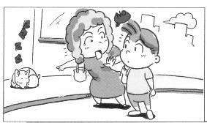 | - Who are they?  - Where are they?  - What do they see?  - What is the animal doing?  - What does Tony’s mom tell him?
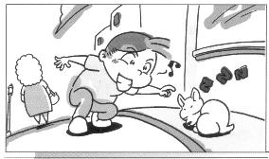 | - Does Tony listen to his mom?  - What is Tony doing?
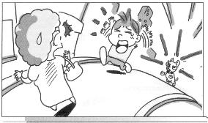 | - How is the dog? Why?  - What happened?  - How are they?

Useful vocabularies and phrases
- sidewalk
- tell sb to do sth
- leave sb alone
- wake sb up
- run after sb / chase after sb

